Project Plan

Virtual Letter of Life (VLOL) Application Development for City of Salisbury Fire Department

Sefanit Urgessa

Mohammed Allibalogun

Robert Garcia

Meron Getachew Debela

Charles Baisie

Augustin Mwamba

Jamal Bourne

SWEN 670 Software Engineering Project

University of Maryland Global Campus

Date: 06/09/2020

**REVISION HISTORY**

|  |  |  |
| --- | --- | --- |
| **Date** | **Version** | **Description** |
| 06/09/2020 | 1.0 | Initial Project Plan Release |
|  |  |  |
|  |  |  |
|  |  |  |

**Table of Contents**

City of Salisbury Fire Department Mission Statement 4

Statement of Need 5

Purpose of Project Plan 6

Project Approach/Milestones 6

Definitions, Acronyms and Abbreviations 6

Scope Management Plan 7

Scope Statement 7

Product Scope Description 7

Product Acceptance Criteria 7

Project Deliverables 7

Project Exclusions 8

Project Constraints 8

Project Assumptions 8

Items Beyond Scope 8

Scope Conclusion 8

Resource Management Plan 8

Project Team Organization 8

Project Team Roles & Responsibilities 9

Requirements Management Plan 10

Purpose 10

Project Requirements 11

Project Breakdown 11

Project Schedule - WBS  12

Product Requirements 15

User Stories/Functional Requirements 15

Software Specifications 16

Change Management Plan 17

Change Management Plan Introduction 17

Change Control Board 17

Roles and Responsibilities 17

Risk Management Plan 18

Introduction 18

Risk Management Procedure and Process 18

Risk Identification, Analysis, and Response 19

Qualitative Analysis 19

Quantitative Analysis 20

Risk Monitoring, Controlling, and Reporting 20

Communication Management Plan 21

Introduction 21

Communication Methodologies & Responsibilities 21

Conclusion 21

References 22

# The City of Salisbury Fire Department Mission Statement

*The City of Salisbury Fire Department – Fire Marshal’s Office exists to ensure the safety and well-being of the citizens, visitors, and business partners of the City of Salisbury; and to stay the effects of conflagration through the promulgation and enforcement of the City Fire Prevention Code, plan review, and public fire & life safety education.*

In support of this mission, the department is undertaking a project to roll out a new Electronic Letter of Life. The Letter of Life is a paper form that provides responders with a list of important medical information regarding the patient in need. This form should be completed by patient and placed inside the residence at a location easily accessible by EMS personnel.

The objective of the project is to develop an interoperable electronic Letter of Life system that will exchange information through the interdisciplinary Emergency Medical Services (EMS), allowing information to be updated and viewed simultaneously by various authorized end users. Additionally, it will provide flexible accessibility to patients to continuoually update their medical information.

# Statement of Need

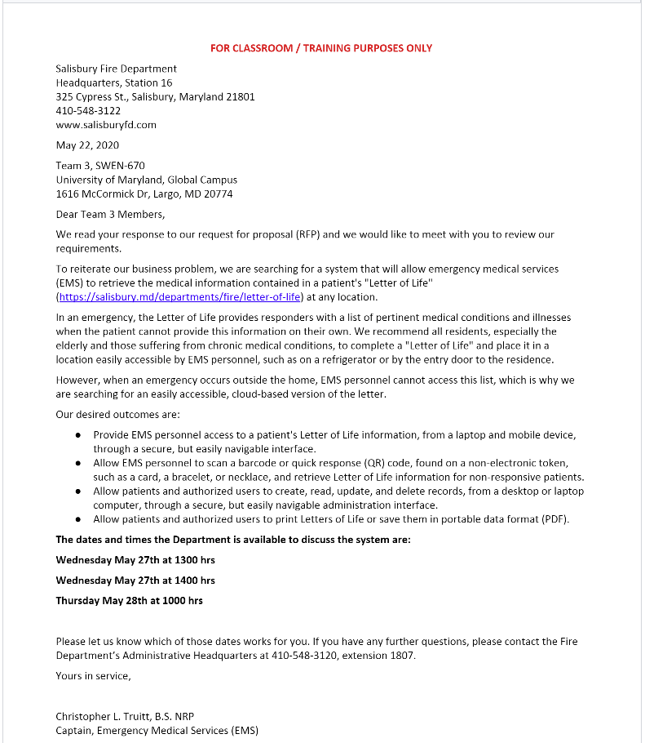

# Purpose of Project Plan

This document will explain how the project team will accomplish the project goals and define the upcoming project milestones. The project plan is a living document that will adapt as needed and approved to ensure the success of this project.

Included sub-plans within this project plan are: scope management plan, resource management plan, requirements management plan, change management plan, risk management plan, and communication management plan. Additionally, the following supporting documents will be constructed to be delivered at stated milestones throughout the different phases of the project life cycle.

* SRS – Use Case Document
* Technical Design Document
* Software Test Plan
* Deployment and Operations Guide (Runbook)
* Programmer Guide
* User Guide
* Test Report

The hybrid agile methodology will be utilized for this project. The project will be managed using the information, directives, steps, and procedures as stated in the project plan.

# Project Approach/Milestones

Milestone I: Requirement gathering & specification document, Project Plan, Team definition

Milestone II: Application design definition & document, development initiation, status meeting with the client

Milestone III: Software test plan, Software testing, Runbook document, Programmer guide document

Milestone IV: Complete application deployment, Test report document, User guide document, Application demonstration meeting with the client

1. **Definitions, Acronyms and Abbreviations**

Below are the terms and abbreviations used in this document:

* EMSPlus – Official name of Project Team 3
* QR code – Quick Response code
* ER – Emergency Responder
* IT – Information Technology
* SRS – Software Requirement Specification
* RACI Matrix – Responsibility Assignment Matrix
* WBS – Work Breakdown Structure
* CRISP – Chesapeake Regional Information System for our Patients
* PMI – Project Management Institute
* PMBOK – Project Management Body of Knowledge
* CCB – Change Control Board
* UI/UX – User Interface/User Experience
* HTML – Hypertext Markup Language
* CSS – Cascading Style Sheet
* LOL – Letter of Life
* VLOL – Virtual Letter of Life
* MIEMSS – Maryland Institute for Emergency Medical Services Systems
* HIPAA – Health Insurance Portability and Accountability Act
* QA – Quality Assurance

1. **Scope Management Plan**
   1. **Scope Statement**

The goal of this project is to develop Virtual Letter of Life that will improve emergency patient care at remote location in which the traditional Letter of Life information is not readily available. This project will utilize the project management method that will provide detailed instructions for the discipline of planning, organizing, reporting and managing project resources to successfully complete project objectives within 10-12 weeks scheduled time frame. The project will end after developing complete & executable software along with all the supporting documents; however the system will be managed and upgraded as per need.

* 1. **Product Scope Description** – The product will allow first responders access to view a list of important medical information regarding the patient in need. In addition, it will provide flexible accessibility to patients to continuously update their medical information.
  2. **Product Acceptance** **Criteria** – The project requires the approval of project sponsor, Captain Christopher L. Truitt. The project plan (this document) and the Software Requirement Specification (SRS) document must be reviewed and approved by the project sponsor.
  3. **Project Deliverables**
* Reduced time spent searching through accurate patient information
* Enhance security to ensure the security of patients’ sensitive data storage and accessibility: allowing information to be viewable to the users with regard to their level of access based upon their level of position.
* Accessibility to patients to easily update their medical information to ensure accurate information sharing between first responders and other authorized personnel
* Personal Health Data will be date and time stamped, inclusive to medication management and continuity of care.
* The system will monitor who is accessing patient information and provide data for audit.
* Patients will be provided a barcode identifier at the time of registration, to be scanned by authorized users to view patient information. This will prevent the open display of patient information increasing security and patient privacy.
  1. **Project Exclusions** – The project exclusions will include any work that is done outside of the project scope statement. As it relates to any administrative task, duties or needs members of project team would need to complete the project.
  2. **Project Constraints** – The set timeline to complete the project is restricted to exact 11 weeks, which includes delivering all stated documents and working software by August 11, 2020.
  3. **Project Assumptions** – The EMSPlus project team are working under the assumption that all credentialed & responsible parties have agreed to proceed with the development of a new electronic Letter of Life to be completed within the next 10-12 weeks from the start to the end of completion.
  4. **Items Beyond Scope**

### The project does not include the following:

* Integration with CRISP – Chesapeake Regional Information System for our Patients
* Integration to the existing information technology (IT) infrastructure of City of Salisbury system
  + The product is designed to seamlessly integrate with the current information technology (IT) infrastructure of City of Salisbury system. However, the actual integration is beyond the scope of this project.
  1. **Scope Conclusion**

This project includes the design, programming, and testing of a new software application for Virtual Letter of Life. The key deliverable for this project is a completed software application. This project will be accepted once the new software has been successfully tested internally and has been approved by the client. This project does not include ongoing operations and maintenance of the software.

## Resource Management Plan

The resource management plan focuses on how the resources will be allocated and utilized to meet the quality and deadlines of project deliverables (PMI, 2018).

### Project Team Organization

The EMSPlus team consists of seven internal team members, each designated for a major role & few additional supporting/backup roles (see table below).

|  |  |
| --- | --- |
| Name | Role |
| Sefanit Urgessa (Sofy) | Project Manager | UI/UX Developer |
| Mohammed Allibalogun | Project Manager | Backend Developer |
| Rob Garcia | Product Owner | Backend Developer |
| Meron Getachew Debela | Documentation Champion |
| Charles Baisie | Security | UI/UX Developer |
| Augustin Mwamba | Database Developer |
| Jamal Bourne | UI/UX Developer |

In addition to the listed seven members, the project will utilize the following external team members that are pertinent to the successful completion of this project.

* Roy Gordon – Project manager, who will provide guideline and consultation support as subject matter expert. He will also serve as the communication pipeline with SWEN 670 professor, Dr. Mir Assadullah.
* Christopher L. Truitt – Client/Project Sponsor, who will approve and all necessary documents (including this document). He will serve as the client that will be receiving the completed product at the end of the project completion.
* DevOps team & Arezo Sanie – The DevOps team & Arezo Sanie will work closely with EMSPlus team to ensure seamless product release and business objectives are being met or exceeded.

### Project Team Roles & Responsibilities

Using the RACI Chart Method, the following chart displays the roles and responsibilities of project team that will be accountable to developing the Virtual Letter of Life software (*Roles & Deliverable details are outlined below the image for clarity purposes*).

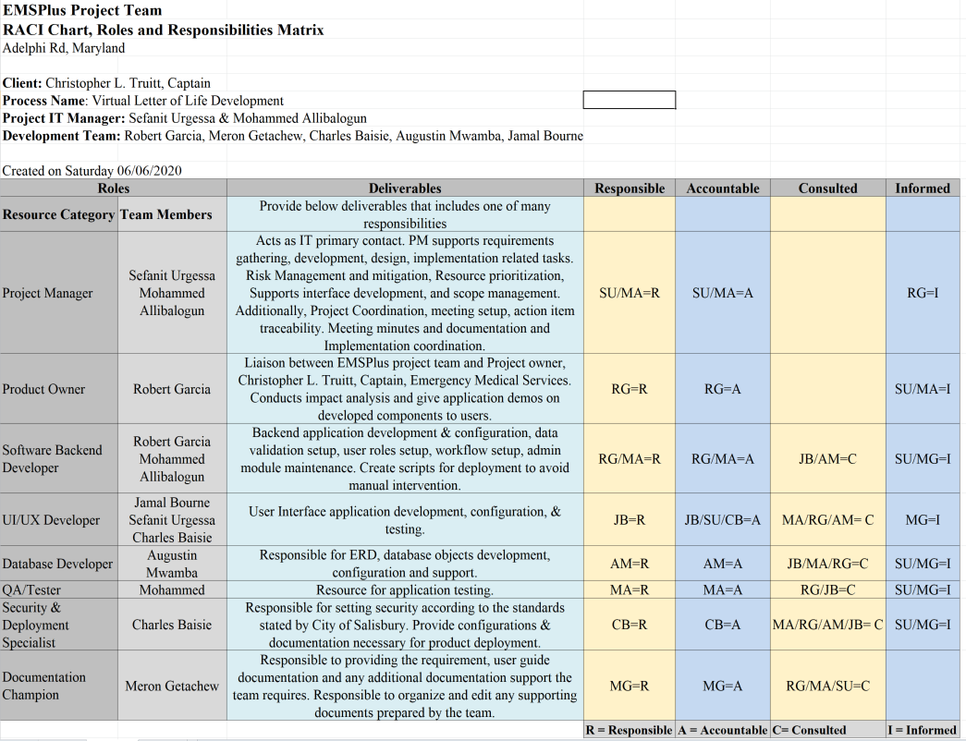

**Roles & Deliverable outline:**

|  |  |
| --- | --- |
| **Roles** | **Deliverables** |
| **Resource Category** | Provide below deliverables that includes one of many responsibilities |
| Project Manager | Acts as IT primary contact. PM supports requirements gathering, development, design, implementation related tasks. Risk Management and mitigation, Resource prioritization, Supports interface development, and scope management. Additionally, Project Coordination, meeting setup, action item traceability. Meeting minutes and documentation and Implementation coordination. |
| Product Owner | Liaison between EMSPlus project team and Project owner, Christopher L. Truitt, Captain, Emergency Medical Services. Conducts impact analysis and give application demos on developed components to users. |
| Software Backend Developer | Backend application development & configuration, data validation setup, user roles setup, workflow setup, admin module maintenance. Create scripts for deployment to avoid manual intervention. |
| UI/UX Developer | User Interface application development, configuration, & testing. |
| Database Developer | Responsible for ERD, database objects development, configuration and support. |
| QA/Tester | Resource for application testing. |
| Security & Deployment Specialist | Responsible for setting security according to the standards stated by City of Salisbury. Provide configurations & documentation necessary for product deployment. |
| Documentation Champion | Responsible to providing the requirement, user guide documentation and any additional documentation support the team requires. Responsible to organize and edit any supporting documents prepared by the team. |

## Requirements Management Plan

### Purpose

The purpose of the Virtual Letter of Life Requirements Management Plan is to establish a common understanding of how requirements were identified, analyzed, documented, and managed for the software development project. Requirements will be divided into two categories: project requirements and product requirements.

Project requirements are the requirements identified to meet the needs of the project and ensure its completion and readiness to hand over to operations. These consist mostly of non-technical requirements. The project requirements are detailed below in the WBS detailing the project schedule along with the project breakdown.

Product requirements are the requirements identified to meet the technical specifications of the product being produced as a result of the project. The User stories section outlines the functional requirements that are approved by the project owner/client. The Software specifications table provides a brief summary of the solution stack that will be utilized for development & documentation of the Virtual Letter of Life software. Additionally, the Software Requirement Specification document will provide detailed information regarding the product requirement specifications.

### Project Requirements

* + 1. **Project Breakdown**

In the below Outline, the project is broken down into components that reflect the readiness of project completion and displays project needs:

|  |  |
| --- | --- |
| Feasibility | Project team meets to discuss feasibility of the proposed project.  * Project team requests & secure sponsorship, define project scope, define and assume role within the team. |
| Initiation | Project team will meet with the project owner/client to review the needs and requirements for the Virtual Letter of Life software.  * Project team will provide solutions and recommendations to make sure all the requirements will be met, and project will be completed accordingly. * Project team will discuss and decides appropriate language and database choices. * Project Manager will prepare the project plan detailing important project information and key milestones and submit for approval. |
| Design | The project team will create system and database design.  * Project team will hold project meeting to approve design and communicate roles and responsibilities of upcoming development phase. |
| Development | Begin designing the Virtual Letter of Life software; inclusive of database, backend, and UI/UX development.  * Perform Unit Testing. |
| Testing | Product testing will be performed according to the test plan.  * Resolve any issues that may arise during testing. * Re-test the software until product runs error free. |
| Closeout | Document records for future project reference.  * Demonstrate and deliver complete software. * Update and deliver project plan and any supporting documents. |

### Project Schedule - WBS

The WBS table provided below shows the detail information of the project schedule from feasibility to closeout stage.

| **WBS** | **Task Name** | **Duration** | **Start** | **Finish** | **Cost** |
| --- | --- | --- | --- | --- | --- |
| **EMS-1** | **Scope and Prep** | **40 hrs** | **Wed 5/20/20** | **Sun 5/24/20** | **$7,000.00** |
| EMS-1.1 | Request Project Sponsorship | 24 hrs | Wed 5/20/20 | Fri 5/22/20 |  |
| EMS-1.2 | Secure Project Sponsorship | 8 hrs | Sat 5/23/20 | Sat 5/23/20 |  |
| **EMS-1.3** | **Team Meeting** | **8 hrs** | **Sun 5/24/20** | **Sun 5/24/20** |  |
| EMS-1.3.1 | Determine Project Scope | 8 hrs | Sun 5/24/20 | Sun 5/24/20 |  |
| EMS-1.3.2 | Define Preliminary Resources | 8 hrs | Sun 5/24/20 | Sun 5/24/20 |  |
| **EMS-2** | **Requirements** | **112 hrs** | **Tue 5/26/20** | **Tue 6/9/20** | **$19,600.00** |
| EMS-2.1 | Procure Required Resources | 8 hrs | Tue 5/26/20 | Tue 5/26/20 |  |
| EMS-2.2 | Needs Analysis with Client | 8 hrs | Wed 5/27/20 | Wed 5/27/20 |  |
| EMS-2.3 | Draft Preliminary Software Specifications | 24 hrs | Thu 5/28/20 | Sat 5/30/20 |  |
| **EMS-2.4** | **Team Meeting** | **8 hrs** | **Sun 5/31/20** | **Sun 5/31/20** |  |
| EMS-2.4.1 | Assign Roles | 8 hrs | Sun 5/31/20 | Sun 5/31/20 |  |
| EMS-2.5 | Requirements Approved by Client | 8 hrs | Mon 6/1/20 | Mon 6/1/20 |  |
| EMS-2.6 | Develop Preliminary Schedule and Budget | 8 hrs | Tue 6/2/20 | Tue 6/2/20 |  |
| EMS-2.7 | Develop Delivery Timeline | 8 hrs | Wed 6/3/20 | Wed 6/3/20 |  |
| EMS-2.8 | Secure Required Resources | 24 hrs | Thu 6/4/20 | Sat 6/6/20 |  |
| **EMS-2.9** | **Team Meeting** | **8 hrs** | **Sun 6/7/20** | **Sun 6/7/20** |  |
| EMS-2.9.1 | Review Software Specifications | 8 hrs | Sun 6/7/20 | Sun 6/7/20 |  |
| EMS-2.9.2 | Review Schedule and Budget | 8 hrs | Sun 6/7/20 | Sun 6/7/20 |  |
| EMS-2.10 | Obtain Approval to Proceed from Client | 8 hrs | Mon 6/8/20 | Mon 6/8/20 |  |
| **EMS-2.11** | **Team Meeting** | **0 hrs** | **Tue 6/9/20** | **Tue 6/9/20** |  |
| EMS-2.11.1 | Incorporate Feedback into Specifications, Schedule and Budget | 0 hrs | Tue 6/9/20 | Tue 6/9/20 |  |
| EMS-2.11.2 | Review Project Plan and SRS | 0 hrs | Tue 6/9/20 | Tue 6/9/20 |  |
| EMS-2.11.3 | Milestone 1 Deliverables Due (Project Plan & SRS) | 0 hrs | Tue 6/9/20 | Tue 6/9/20 |  |
| **EMS-3** | **Design** | **56 hrs** | **Wed 6/10/20** | **Tue 6/16/20** | **$9,800.00** |
| EMS-3.1 | Develop Backlog and Prototype | 32 hrs | Wed 6/10/20 | Sat 6/13/20 |  |
| **EMS-3.2** | **Team Meeting** | **8 hrs** | **Sun 6/14/20** | **Sun 6/14/20** |  |
| EMS-3.2.1 | Review Product Backlog | 8 hrs | Sun 6/14/20 | Sun 6/14/20 |  |
| EMS-3.2.2 | Review Prototype | 8 hrs | Sun 6/14/20 | Sun 6/14/20 |  |
| EMS-3.3 | Obtain Approval to Proceed from Client | 8 hrs | Mon 6/15/20 | Mon 6/15/20 |  |
| EMS-3.4 | Incorporate feedback into Product Backlog | 8 hrs | Tue 6/16/20 | Tue 6/16/20 |  |
| **EMS-4** | **Development** | **272 hrs** | **Wed 6/17/20** | **Tue 7/21/20** | **$47,600.00** |
| **EMS-4.1** | **Sprint 1** | **56 hrs** | **Wed 6/17/20** | **Tue 6/23/20** |  |
| EMS-4.1.1 | Development Sprint | 32 hrs | Tue 6/16/20 | Fri 6/19/20 |  |
| EMS-4.1.2 | Sprint Review with Client | 8 hrs | Sat 6/20/20 | Sat 6/20/20 |  |
| **EMS-4.1.3** | **Team Meeting** | **8 hrs** | **Sun 6/21/20** | **Sun 6/21/20** |  |
| EMS-4.1.3.1 | Sprint Retrospective | 8 hrs | Sun 6/21/20 | Sun 6/21/20 |  |
| EMS-4.1.3.2 | Product Backlog Reassessment | 8 hrs | Sun 6/21/20 | Sun 6/21/20 |  |
| **EMS-4.1.4** | **Sprint Closeout** | **8 hrs** | **Mon 6/22/20** | **Mon 6/22/20** |  |
| EMS-4.1.4.1 | Static Code Analysis | 8 hrs | Mon 6/22/20 | Mon 6/22/20 |  |
| EMS-4.1.4.2 | Unit Testing | 8 hrs | Mon 6/22/20 | Mon 6/22/20 |  |
| EMS-4.1.4.3 | Comments and Styling | 8 hrs | Mon 6/22/20 | Mon 6/22/20 |  |
| EMS-4.1.4.4 | Release and Archive | 8 hrs | Mon 6/22/20 | Mon 6/22/20 |  |
| **EMS-4.2** | **Sprint 2** | **56 hrs** | **Tue 6/23/20** | **Mon 6/29/20** |  |
| EMS-4.2.1 | Development Sprint | 24 hrs | Wed 6/24/20 | Fri 6/26/20 |  |
| **EMS-4.2.2** | **Team Meeting** | **0 hrs** | **Tue 6/23/20** | **Tue 6/23/20** |  |
| EMS-4.2.2.1 | Review Technical Design Document | 0 hrs | Tue 6/23/20 | Tue 6/23/20 |  |
| EMS-4.2.2.2 | Review Test Plan | 0 hrs | Tue 6/23/20 | Tue 6/23/20 |  |
| EMS-4.2.2.3 | Milestone 2 Deliverables Due (Tech Design & Test Plan) | 0 hrs | Tue 6/23/20 | Tue 6/23/20 |  |
| EMS-4.2.3 | Sprint Review with Client | 8 hrs | Sat 6/27/20 | Sat 6/27/20 |  |
| **EMS-4.2.4** | **Team Meeting** | **8 hrs** | **Sun 6/28/20** | **Sun 6/28/20** |  |
| EMS-4.2.4.1 | Sprint Retrospective | 8 hrs | Sun 6/28/20 | Sun 6/28/20 |  |
| EMS-4.2.4.2 | Product Backlog Reassessment | 8 hrs | Sun 6/28/20 | Sun 6/28/20 |  |
| **EMS-4.2.5** | **Sprint Closeout** | **8 hrs** | **Mon 6/29/20** | **Mon 6/29/20** |  |
| EMS-4.2.5.1 | Static Code Analysis | 8 hrs | Mon 6/29/20 | Mon 6/29/20 |  |
| EMS-4.2.5.2 | Unit Testing | 8 hrs | Mon 6/29/20 | Mon 6/29/20 |  |
| EMS-4.2.5.3 | Comments and Styling | 8 hrs | Mon 6/29/20 | Mon 6/29/20 |  |
| EMS-4.2.5.4 | Release and Archive | 8 hrs | Mon 6/29/20 | Mon 6/29/20 |  |
| **EMS-4.3** | **Sprint 3** | **48 hrs** | **Tue 6/30/20** | **Mon 7/6/20** |  |
| EMS-4.3.1 | Development Sprint | 24 hrs | Tue 6/30/20 | Thu 7/2/20 |  |
| EMS-4.3.2 | Sprint Review with Client | 8 hrs | Fri 7/3/20 | Fri 7/3/20 |  |
| **EMS-4.3.3** | **Team Meeting** | **8 hrs** | **Sun 7/5/20** | **Sun 7/5/20** |  |
| EMS-4.3.3.1 | Sprint Retrospective | 8 hrs | Sun 7/5/20 | Sun 7/5/20 |  |
| EMS-4.3.3.2 | Product Backlog Reassessment | 8 hrs | Sun 7/5/20 | Sun 7/5/20 |  |
| **EMS-4.3.4** | **Sprint Closeout** | **8 hrs** | **Mon 7/6/20** | **Mon 7/6/20** |  |
| EMS-4.3.4.1 | Static Code Analysis | 8 hrs | Mon 7/6/20 | Mon 7/6/20 |  |
| EMS-4.3.4.2 | Unit Testing | 8 hrs | Mon 7/6/20 | Mon 7/6/20 |  |
| EMS-4.3.4.3 | Comments and Styling | 8 hrs | Mon 7/6/20 | Mon 7/6/20 |  |
| EMS-4.3.4.4 | Release and Archive | 8 hrs | Mon 7/6/20 | Mon 7/6/20 |  |
| **EMS-4.4** | **Sprint 4** | **56 hrs** | **Tue 7/7/20** | **Mon 7/13/20** |  |
| EMS-4.4.1 | Development Sprint | 32 hrs | Tue 7/7/20 | Fri 7/10/20 |  |
| EMS-4.4.2 | Sprint Review with Client | 8 hrs | Sat 7/11/20 | Sat 7/11/20 |  |
| **EMS-4.4.3** | **Team Meeting** | **8 hrs** | **Sun 7/12/20** | **Sun 7/12/20** |  |
| EMS-4.4.3.1 | Sprint Retrospective | 8 hrs | Sun 7/12/20 | Sun 7/12/20 |  |
| EMS-4.4.3.2 | Product Backlog Reassessment | 8 hrs | Sun 7/12/20 | Sun 7/12/20 |  |
| **EMS-4.4.4** | **Sprint Closeout** | **8 hrs** | **Mon 7/13/20** | **Mon 7/13/20** |  |
| EMS-4.4.4.1 | Static Code Analysis | 8 hrs | Mon 7/13/20 | Mon 7/13/20 |  |
| EMS-4.4.4.2 | Unit Testing | 8 hrs | Mon 7/13/20 | Mon 7/13/20 |  |
| EMS-4.4.4.3 | Comments and Styling | 8 hrs | Mon 7/13/20 | Mon 7/13/20 |  |
| EMS-4.4.4.4 | Release and Archive | 8 hrs | Mon 7/13/20 | Mon 7/13/20 |  |
| **EMS-4.5** | **Sprint 5** | **56 hrs?** | **Tue 7/14/20** | **Mon 7/20/20** |  |
| EMS-4.5.1 | Development Sprint | 32 hrs | Tue 7/14/20 | Fri 7/17/20 |  |
| **EMS-4.5.2** | **Team Meeting** | **0 hrs** | **Tue 7/14/20** | **Tue 7/14/20** |  |
| EMS-4.5.2.1 | Review Programmer Guide | 0 hrs | Tue 7/14/20 | Tue 7/14/20 |  |
| EMS-4.5.2.2 | Review Runbook | 0 hrs | Tue 7/14/20 | Tue 7/14/20 |  |
| EMS-4.5.2.3 | Milestone 3 Deliverables Due (Programmer Guide & Runbook) | 0 hrs | Tue 7/14/20 | Tue 7/14/20 |  |
| EMS-4.5.3 | Sprint Review with Client | 8 hrs | Sat 7/18/20 | Sat 7/18/20 |  |
| **EMS-4.5.4** | **Team Meeting** | **8 hrs** | **Sun 7/19/20** | **Sun 7/19/20** |  |
| EMS-4.5.4.1 | Sprint Retrospective | 8 hrs | Sun 7/19/20 | Sun 7/19/20 |  |
| EMS-4.5.4.2 | Product Backlog Reassessment | 8 hrs | Sun 7/19/20 | Sun 7/19/20 |  |
| **EMS-4.5.5** | **Sprint Closeout** | **8 hrs** | **Mon 7/20/20** | **Mon 7/20/20** |  |
| EMS-4.5.5.1 | Static Code Analysis | 8 hrs | Mon 7/20/20 | Mon 7/20/20 |  |
| EMS-4.5.5.2 | Unit Testing | 8 hrs | Mon 7/20/20 | Mon 7/20/20 |  |
| EMS-4.5.5.3 | Comments and Styling | 8 hrs | Mon 7/20/20 | Mon 7/20/20 |  |
| EMS-4.5.5.4 | Release and Archive | 8 hrs | Mon 7/20/20 | Mon 7/20/20 |  |
| **EMS-5** | **Testing and Documentation** | **64 hrs** | **Tue 7/21/20** | **Tue 7/28/20** | **$11,200.00** |
| **EMS-5.1** | **Final Testing** | **24 hrs** | **Tue 7/21/20** | **Thu 7/23/20** |  |
| EMS-5.1.1 | Integration Testing | 8 hrs | Tue 7/21/20 | Tue 7/21/20 |  |
| EMS-5.1.2 | Vulnerability Scanning | 8 hrs | Wed 7/22/20 | Wed 7/22/20 |  |
| EMS-5.1.3 | Penetration Testing | 8 hrs | Thu 7/23/20 | Thu 7/23/20 |  |
| EMS-5.2 | Draft User Guide | 16 hrs | Fri 7/24/20 | Sat 7/25/20 |  |
| **EMS-5.3** | **Team Meeting** | **8 hrs** | **Sun 7/26/20** | **Sun 7/26/20** |  |
| EMS-5.3.1 | Review User Guide | 8 hrs | Sun 7/26/20 | Sun 7/26/20 |  |
| EMS-5.3.2 | Review Test Report | 8 hrs | Sun 7/26/20 | Sun 7/26/20 |  |
| EMS-5.4 | Test and Documentation Review with Client | 8 hrs | Mon 7/27/20 | Mon 7/27/20 |  |
| EMS-5.5 | Incorporate feedback into User Guide and Test Report | 8 hrs | Tue 7/28/20 | Tue 7/28/20 |  |
| **EMS-5.6** | **Team Meeting** | **0 hrs** | **Tue 7/28/20** | **Tue 7/28/20** |  |
| EMS-5.6.1 | Incorporate Feedback into Specifications, Schedule and Budget | 0 hrs | Tue 7/28/20 | Tue 7/28/20 |  |
| EMS-5.6.2 | Review User Guide & Test Report | 0 hrs | Tue 7/28/20 | Tue 7/28/20 |  |
| EMS-5.6.3 | Milestone 4 Deliverables Due (User Guide & Test Report) | 0 hrs | Tue 7/28/20 | Tue 7/28/20 |  |
| **EMS-6** | **Training** | **48 hrs** | **Wed 7/29/20** | **Mon 8/3/20** | **$8,400.00** |
| EMS-6.1 | Draft Training Plan | 8 hrs | Wed 7/29/20 | Wed 7/29/20 |  |
| EMS-6.2 | Draft Final Presentation | 8 hrs | Thu 7/30/20 | Thu 7/30/20 |  |
| EMS-6.3 | Draft Incident Response Plan | 8 hrs | Fri 7/31/20 | Fri 7/31/20 |  |
| EMS-6.4 | Draft Patch and Update Plan | 8 hrs | Sat 8/1/20 | Sat 8/1/20 |  |
| **EMS-6.5** | **Team Meeting** | **8 hrs** | **Sun 8/2/20** | **Sun 8/2/20** |  |
| EMS-6.5.1 | Review Training Plan | 8 hrs | Sun 8/2/20 | Sun 8/2/20 |  |
| EMS-6.5.2 | Review Final Presentation Draft | 8 hrs | Sun 8/2/20 | Sun 8/2/20 |  |
| EMS-6.5.3 | Review Incident Response Plan | 8 hrs | Sun 8/2/20 | Sun 8/2/20 |  |
| EMS-6.5.4 | Review Patch and Update Plan | 8 hrs | Sun 8/2/20 | Sun 8/2/20 |  |
| EMS-6.6 | Training, Incident Response, and Maintenance Plan Review with Client | 8 hrs | Mon 8/3/20 | Mon 8/3/20 |  |
| **EMS-7** | **Deployment** | **64 hrs** | **Tue 8/4/20** | **Tue 8/11/20** |  |
| EMS-7.1 | Certify Release and Archive | 24 hrs | Tue 8/4/20 | Thu 8/6/20 | $4,200.00 |
| **EMS-7.2** | **Team Meeting** | **8 hrs** | **Fri 8/7/20** | **Fri 8/7/20** |  |
| EMS-7.2.1 | Rehearse Final Presentation | 8 hrs | Fri 8/7/20 | Fri 8/7/20 |  |
| EMS-7.3 | Final Presentation | 8 hrs | Sat 8/8/20 | Sat 8/8/20 |  |
| EMS-7.4 | Upload Project Code and Deliverables to GitHub | 8 hrs | Sun 8/9/20 | Sun 8/9/20 |  |
| EMS-7.5 | Final Team Meeting | 8 hrs | Mon 8/10/20 | Mon 8/10/20 |  |
| EMS-7.6 | End of Course | 8 hrs | Tue 8/11/20 | Tue 8/11/20 |  |
|  |  | **616 hrs** |  |  | **$107,800.00** |

### Product Requirements

### User Stories/Functional Requirements

* Unauthenticated and Unauthorized User
  + Access to an informative Landing page to learn about the Letter of Life program.
  + Access to a Contact page for information solicitation about the Letter of Life program or contact the System Administrator about an issue.
  + Access to a secure Registration page to enroll in the Letter of Life program.
* Program Participant
  + Access to secure Letter of Life Login Page.
  + View/Add/Edit/Delete Letter of Life information.
  + Print a barcode or quick response (QR) code with a link to Letter of Life (which may be affixed to a bracelet, card, or necklace), so medical personnel can quickly access patient’s medical history in case of an emergency.
  + Access to a secure Contact page to contact Patient Advocate (if designated) and/or the System Administrator about an issue.
* Medical Services Provider
  + Access the Letter of Life system via a Login Page, so unauthenticated and unauthorized users cannot access a patient's medical history.
  + Edit profile information via an online form to ensure profile information is up to date.
  + Search & View for patients on a laptop or mobile device via an online form to retrieve their medical history and provide correct medical care.
  + Search & View for a patient by scanning a barcode or quick response (QR) code, using a mobile device or authorized accessory.
  + Print a MIEMSS-approved Short Form, populated with patient's information, to provide non-system medical facilities and staff with patient's medical history.
  + Access to a secure Contact page to contact the System Administrator about an issue.
* Patient Agent
  + Access the Letter of Life system via a Login Page.
  + Edit my profile information via an online form to ensure profile information is up to date.
  + Search for patients on a laptop or mobile device via an online form, to view, edit, and print patient information, as necessary.
  + Search for a patient by scanning a barcode or quick response (QR) code, using a mobile device or authorized accessory, to view, edit, and print patient information, as necessary.
  + Access to a secure Contact page to contact the System Administrator about an issue.
* System Administrator
  + Access the VLOL system via a Login Page.
  + Search for user accounts on a laptop or mobile device via an online form to add, view, edit, and delete user accounts, as necessary.
  + View/Add/Edit/Delete accounts for Medical Services Providers and Patient Advocates to limit non-patient access to patient information.
  + View a system error log to inform the development team of problems or issues with the application.
  + View a system activity log, so I can audit access and use of the system.
  + Access to a user guide to provide users with instructions on how to use the system.
    1. **Software Specifications**

|  |  |
| --- | --- |
| Operating System | Windows Server 2019 |
| Web Server | Microsoft Internet Information Services (IIS) 10.0 |
| Database Server | Microsoft Server 2019 |
| Database Language | Microsoft Structured Query Language (SQL) |
| Language and Framework | C# 8.0 / .NET Core 3.1 /HTML/CSS/JavaScript |
| Repository | GitHub/UMGC Repository |
| Development Hosting | HostGator Windows Server (https://vletteroflife.rgcoding.com) using 2048-bit SSL/TLS (single solution stack) |
| Production Hosting | Microsoft Azure Government (GovCloud) Windows Server using 2048-bit SSL/TLS (stack split and domain TBD) |

## Change Management Plan

### Change Management Plan Introduction

To ensure success, this project will use change management. According to Project Management Institute’s (PMI’s) Project Management Body of Knowledge (PMBOK) guide, the purpose of a change management plan is to define the processes for handling change requests (2018). The main purpose of change management plan is to manage change to prevent project failure.

According to PMI’s PMBOK, baselines are established for cost, schedule, and scope. Any request that could cause a change to either of these baselines is a change. Another type of change is document changes; in particular changes to the project management plan that impact how the project is managed.

### Change Control Board

The Virtual Letter of Life project will utilize the EMSPlus team to manage any changes that may arise via team imposed Change Control Board (CCB). The Change Control Board is a committee charged with evaluating changes and giving authorizations to changes. The CCB will go over change requests to evaluate the impact to the project and the need for the change. From there, the CCB approves the change, rejects the change, or requests more information (Project Management Knowledge, 2018). In this project the CCB is authorized to approve development changes that will not impact the schedule product release date. The CCB is also given full authorization over document changes. The CCB members in this project are:

|  |  |  |
| --- | --- | --- |
| **Name** | **Position** | **CCB Role** |
| Robert Garcia | Product Owner | Backend Developer | CCB Chair |
| Sefanit Urgessa | Project Manager | UI/UX Developer | CCB Co-Chair |
| Mohammed Allibalogun | Project Manager | Backend Developer | CCB Co-Chair |
| Meron Getachew Debela | Documentation Champion | CCB Member |
| Charles Baisie | Security | UI/UX Developer | CCB Member |
| Augustin Mwamba | Database Developer | CCB Member |
| Jamal Bourne | UI/UX Developer | CCB Member |

Additionally, any changes that affect the design and infrastructure of the software will be shared with the UMGC DevOps team.

### Roles and Responsibilities

It is important all project members understand their roles & responsibilities. Additionally, it is essential that this is communicated. The roles are as follows

Product Owner/ CCB Chair:

* Chair the CCB
* Make the final decision on changes

IT Project Manager/ CCB Co-Chair:

* Co-Chair the CCB
* Make administrative changes to support decisions in the CCB
* Receive change requests from stakeholders
* Conducted initial change request impact research

Product Developers/ CCB Member

* Partake in the CCB
* Work with the IT Project Manager to research initial change requests
* Participate in the decision process

## Risk Management Plan

* 1. **Introduction**

Risk is a positive or negative event that has 1 - 99% possibility of occurring during a project life cycle. A positive risk is an opportunity that will better the project; whereas negative risk threatens the project’s successful completion (*Positive and negative risks and how to handle it. (2016, October 27)).* The risk management plan allows project managers to anticipate the possibility of both types of risks and prepare adequately to prevent negative risks or use positive risks to better project outcome. This risk management plan outlines possible risks, impacts, and resolutions for the Virtual Letter of Life development project.

### Risk Management Procedure and Process

All parties involved with the project including project sponsors and the project team will work with the project manager to identify, analyze the impact, and propose a solution for project risks. Identifying risks in early stages of the project is important to avoid the risk or respond quickly upon facing the risk. The risk management plan will adhere to the following risk management process *(Risk Management Procedure. (2018, June 28))*:

* Identify risks and source of possible risks
* Qualitative and quantitative analysis of risks by listing possibility, severity, and impact of perceived risk on the project
* Risk response/contingency plan
* Risk monitoring and controlling plan

### Risk Identification, Analysis, and Response

Below is a list of perceived risks, risk analysis, and risk response, which will minimize the impact on the project.

* + 1. **Qualitative Analysis*:*** The project team have identified and assessed the following risks.

|  |  |  |  |
| --- | --- | --- | --- |
| **Risk** | **Possibility/Risk Level (low/medium/high)** | **Mitigation Plan (what to do avoid risk)** | **Contingency Plan (Solution if risk occurs)** |
| Unable to maintain project schedule | Low | * complete thorough analysis of current workflow * account for all possible high-level risks that would affect the project * incorporate shorter task deadlines * frequently review project status | * Identify problem source for the delay * Re-adjust project schedule based on the analysis * Meet with project owners to inform issue & present contingency plan |
| Project scope creep | Low | * Frequent review of the original project scope and weekly sprint meeting | * Enforce that all additional requests to be documents separately, in amendment |
| System incompatibility | Low | * Product development tool (language and database choice) is based on the current IT infrastructure of City of Salisbury | * Meet with IT manager and present contingency plan |
| Unclear/misinterpreted Requirement | Low | * Requirements must be reviewed and agreed upon before project development phase * Frequent meeting to review requirements and ensure expected result consistency | * High-level requirement evaluation with project owners and product owner |
| Lack of commitment from key project personnel | Low | * Personnel engagement is well established * Prepare standard communication plan that outlines important dates * Prepare backup personnel for every development role | * Review and modify the role/responsibility of the personnel |
| Lack of user acceptance | Low | * Make sure users’ input is recognized during requirement gathering * Provide demonstration to clients at various stages of development to ensure familiarity of the system * Ensure the system interface is user friendly and passes QA by selected user groups | * Modify and increase training type and time * Depending on severity of push back, modify some features to ensure end users utilize the tool effectively |
| Data privacy compliance | Low | * Make sure every personnel that is involved in data processing is well trained and abide by HIPAA rules/regulations * Ensure data model and system structure follows HIPAA guidelines | * Send responsible personnel to health data privacy and compliance training * Review and adjust data model to meet patient privacy compliance |

### 

### 10.3.2. Quantitative Analysis

|  |  |  |  |
| --- | --- | --- | --- |
| **Risk** | **Possibility** | **Impact** | **Total Score** |
| Unable to maintain project schedule | .1 | .4 | .04 |
| Project scope creep | .1 | .2 | .02 |
| System incompatibility | .1 | .9 | .09 |
| Unclear/misinterpreted Requirement | .1 | .4 | .04 |
| Lack of commitment from key project personnel | .1 | .4 | .04 |
| Lack of user acceptance | .5 | .5 | .25 |
| Data privacy compliance | .1 | .9 | .09 |

### Risk Monitoring, Controlling, and Reporting

The risk management plan provides the project team the ability to monitor possible risks and the ability to control the occurrence and outcomes of perceived risks. Project team members and expertise will assess the risk registry and update as needed prior to development phase. This will decrease the possibility of unregistered risk occurrence. Additionally, frequent and standard meetings and reports will be practiced to minimize negative risks and increasing the exploitation of positive risks.

# Communication Management Plan

* 1. **Introduction**

Communication between all parties involved in a project is vital. Effective communication or lack of will determine the success or failure of a project, respectively. A communication management plan is an important and simple tool that enables effective communication on a project within and between the project team, the client, and other stakeholders. It provides clear guidelines for how information will be shared, the responsible parties involved for every step of the project life cycle, and who needs to be included in on each project communication.

* 1. **Communication Methodologies & Responsibilities**

The EMSPlus team will continuoually and openly communicate using the following methodologies: Google Hangout, Email, Zoom, and GIT Repository.

* For quick information exchange regarding clarification or reminder – Google Hangout
* For official communication, including document draft/information sharing – Email
* All meetings, including but not to limited to sprint meeting, milestone checkpoint meeting, DevOps-Team meeting, client-team meeting, external PM-team meeting, and any additional administrative or development related meeting – Zoom
* Instructions, documentations, codes – GIT Repository

The following are the designated roles and responsibilities:

* All internal team meeting will be scheduled by the communication personnel, Mohammed Allibalogun, who is responsible for sending out Zoom invites and reminder notification via Google Hangout. Internal meeting include but are not limited to:
  + Weekly project status review, including potential issue/delay and to-do for the following week
  + Frequent Email for information sharing and official documents
  + Google Hangout notifications
  + Continuous GIT code/document repository
* All project team - DevOps meeting will be scheduled by the communication personnel, Mohammed Allibalogun, who is responsible for sending out Zoom invites.
* All Client-Team meetings will be scheduled by Robert Garcia, who will function as a liaison between the client and project team.
* Meeting between External PM & Internal PMs (and documentation champion) will be the responsibility of the internal project managers, Sefanit Urgessa & Mohammed Allibalogun.
* All project milestone submissions will be reviewed by the team via zoom and submitted at milestone by internal PMs, Sefanit Urgessa & Mohammed Allibalogun.

# Conclusion

The project plan will be used to ensure the successful delivery of the Virtual Letter of Life project deliverables. In following this plan, EMSPlus team will ensure the Virtual Letter of Life software will be developed at the highest standard and available for use by the stated project end date; August 11, 2020. It is important this plan is followed as the project will increase emergency patient care and better utilization of resources.

# References

K. (n.d.). Schedule a project with a work breakdown structure (Dynamics 365 for Project Service Automation). Retrieved June 02, 2020, from https://docs.microsoft.com/en-us/dynamics365/customer-engagement/project-service/schedule-project-work-breakdown-structure

Piscapo, M. (2018). Requirements Management Plan. Retrieved June 02, 2020, from http://www.projectmanagementdocs.com/project-planning-templates/requirements-management-plan.html#axzz5J6f4HgMC

Piscopo, M. (2018). Change Management Plan. Retrieved June 02, 2020, from http://www.projectmanagementdocs.com/project-planning-templates/change-management-plan.html

Positive and negative risks and how to handle it. (2016, October 27). Retrieved May 30, 2020, from https://bakkah.net.sa/positive-and-negative-risks-and-how-to-handle-it/

Project Management Institute, Inc. (PMI®) (2017). *A Guide to the Project Management Body of Knowledge, Sixth Edition*.

Watt, A., W., & A. (2014, August 15). Project Management. Retrieved May 30, 2020, from https://opentextbc.ca/projectmanagement/chapter/chapter-9-scope-planning-project-management/